MINISTRY OF EDUCATION AND SCIENCE OF UKRAINE

NATIONAL TECHNICAL UNIVERSITY   
“KHARKIV POLYTECHNIC INSTITUTE”

Department of Software Engineering and Management Information Technology

REPORT

on laboratory work # 3

on the discipline

“python frameworks”

Executed by

Student of the group KN-218g.e

Karyna OHOL

Checked by

Ass. Prof. of department “SEMIT”

Svitlana KOVALENKO

Kharkiv 2020

SOLVING LINEAR PROGRAMMING TASKS USING PYTHON EXTERNAL LIBRARIES

**Objectives**

1. Modelling and solving linear programming problem:

a. Choose assignment according to the number in the group journal.

b. Describe the entered variables.

c. Create a mathematical model of the problem.

d. Find the solution using graphical representation of linear programming problem. The figure should contain lines with their equations, shaded halfplane that satisfy the original inequalities, the feasible region, the point of optimal solution, level curve.

e. Solve the problem using scipy.optimize.

f. Solve the problem using pulp.LpProblem.

g. Compare solutions using np.allclose().

h. Compare the time to solve the problem using scipy.optimize and pulp.LpProblem.

i. Explain the result.

2. Solving transportation problem.

a. Describe the entered variables.

b. Create a mathematical model of the problem.

c. Solve the problem using scipy.optimize.

d. Explain the result.

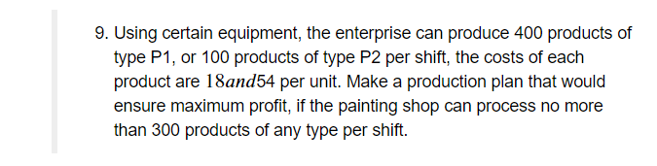

–

**Implementation**

Task 1:

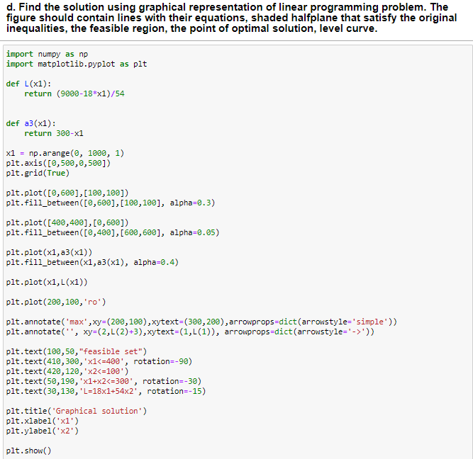

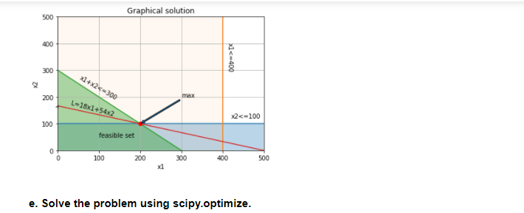

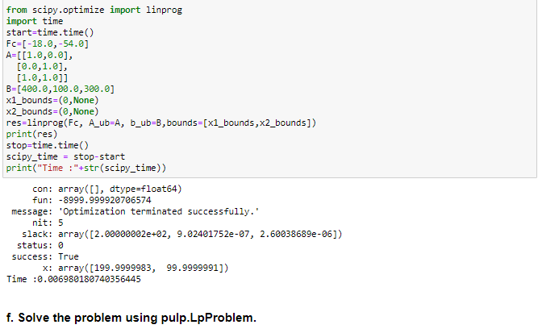

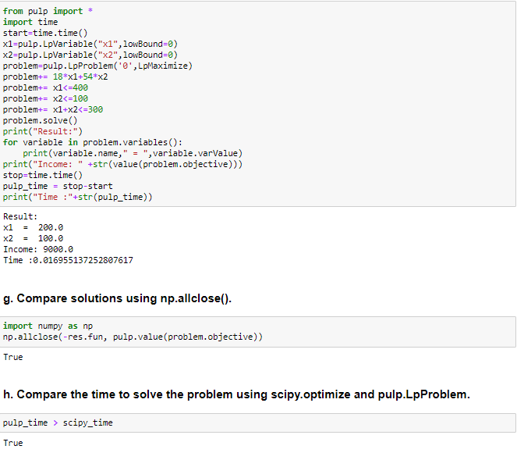

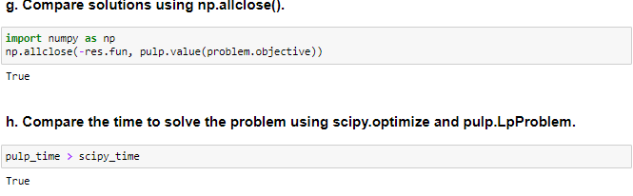

Task 2:

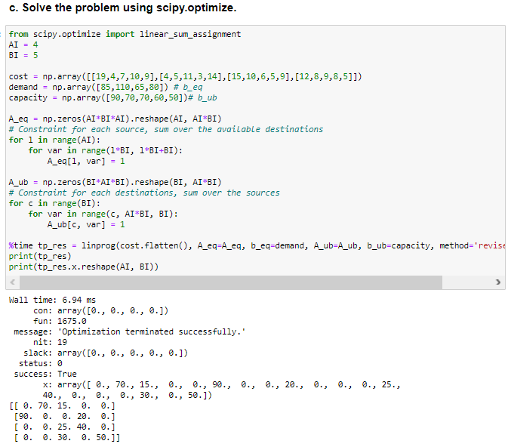

**Conclusions**

Python has powerful libraries to solve linear programming task. The most popular are SciPY and PULP. They both work correct and produce similar valid results. However, it occurs that SciPy works a bit faster, but has less optional parameters that allow to formulate the task more clearly. As for PULP, it has a lot of options, which allow to work with this library in more flexible way.